

Performance Evaluation of CPU Scheduling Algorithms
Submission Date: May 16

Rawan Abdo 20230946
raw20230946@std.psut.edu.jo
Yazan Rayyan 20210050
yaz20210050@std.psut.edu.jo
Sawzar Arsalan 20201113
saw2020113@std.psut.edu.jo

Contents
Introduction: 3
1. First come first served (FCFS) 4
2. Round Robin 5
3. Shortest Job First (SJF) 9
Results: 11
Conclusion: 11
Ranking: 12
References: 13

Introduction:
The goal of this project is to write code and compare three CPU scheduling algorithms: First-Come First-Served (FCFS) - Non-Preemptive, Round Robin (RR) - Preemptive, and Shortest-Job-First (SJF) - Non-Preemptive. The analysis will be performed through measuring each algorithm’s average turnaround time and average waiting time. Each algorithm will be implemented in Python.

First come first served (FCFS)

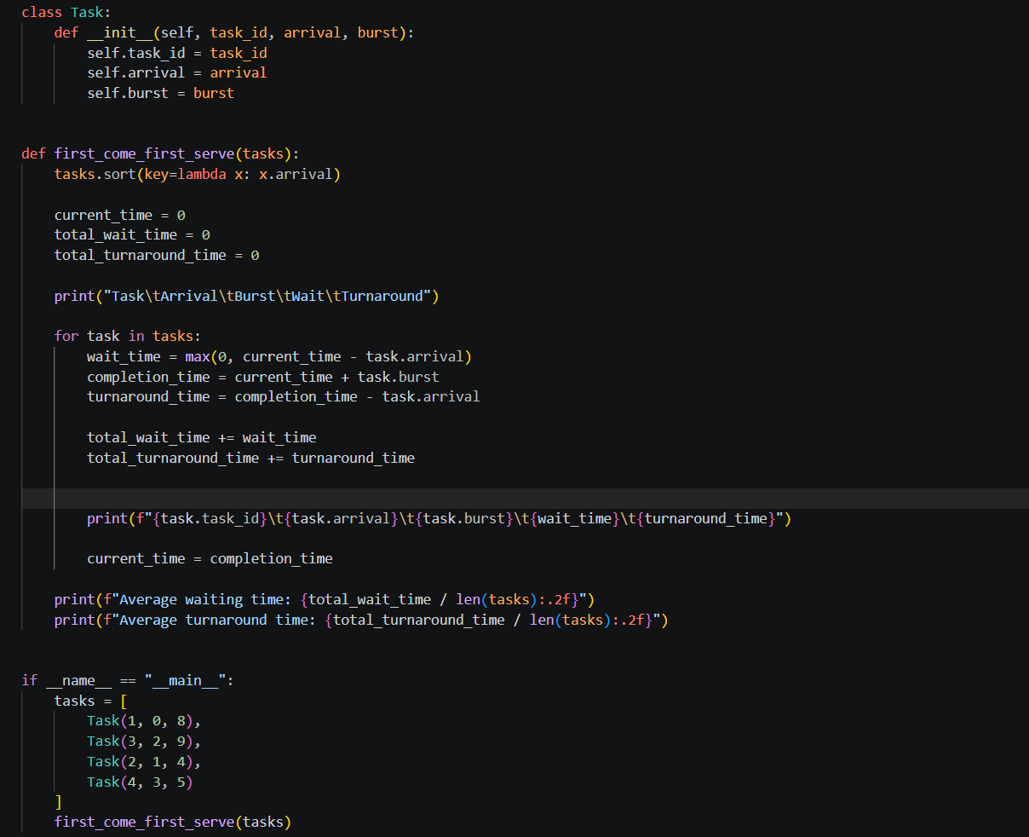

Explanation: The First-Come-First-Served (FCFS) scheduling algorithm can be implemented using a process class that includes attributes such as the process ID, the arrival time of each process, and the burst time of each process. The first_come_first_serve function takes a list of processes, sorts them according to their arrival times, and calculates various time attributes of each process. Using the code provided, a list of processes is passed through the FCFS scheduling algorithm, and the algorithm outputs the waiting time and turnaround time for each process, as well as the average waiting time and turnaround time.

Round Robin
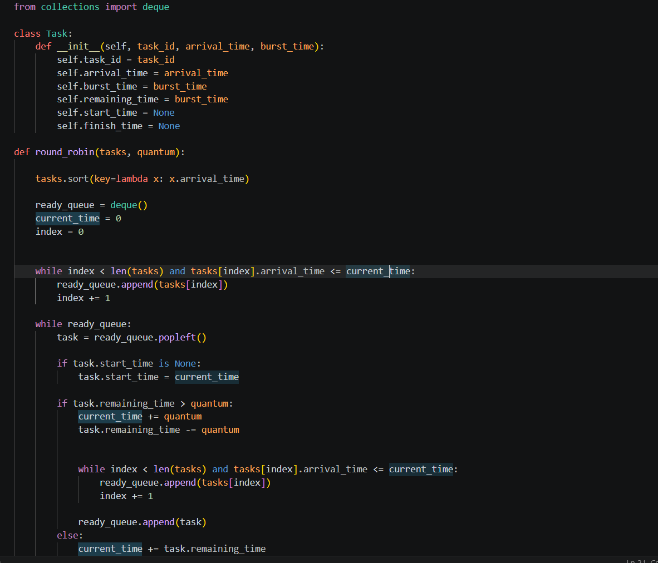
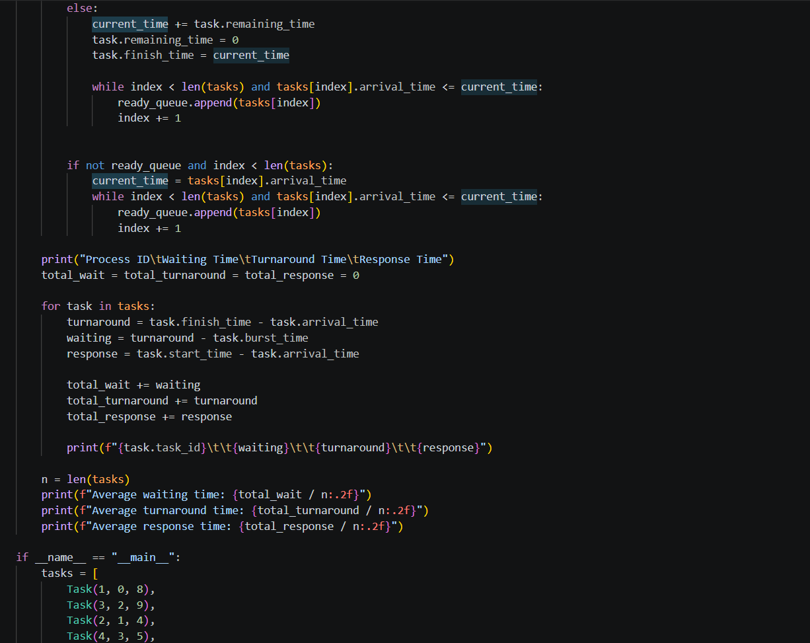
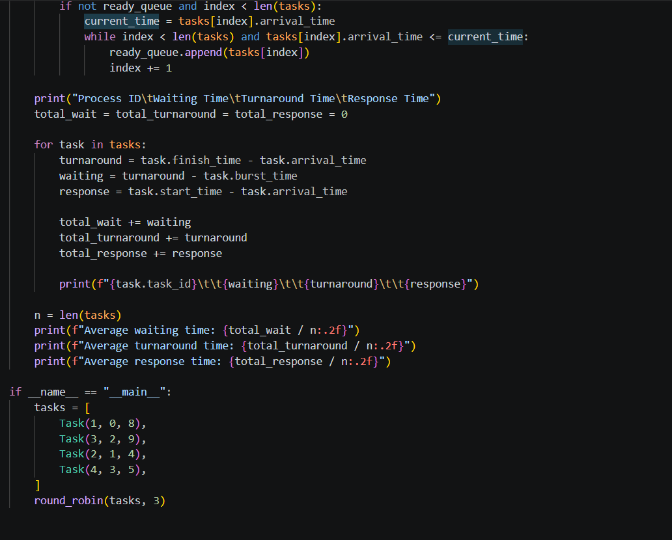
Explanation: The Round Robin scheduling algorithm is a form of preemptive scheduling where each process is allocated a time slice or time quantum to execute.
In the code, a class named Task is used to represent each process. The round_robin function implements the scheduling algorithm. Processes are maintained in a queue, and each process in the queue has its arrival and remaining time checked. If the time remaining for a process is greater than the time quantum, the process is placed back into the queue with the time remaining for that process updated. Otherwise, the process is considered complete, and its waiting time and turnaround time are calculated. Response time is also calculated for each process, which is the time between the arrival of a process and the start of its execution. A summary of each process is printed with its waiting time, turnaround time, and response time. Additionally, averages for each time metric are calculated and displayed.

Shortest Job First (SJF)
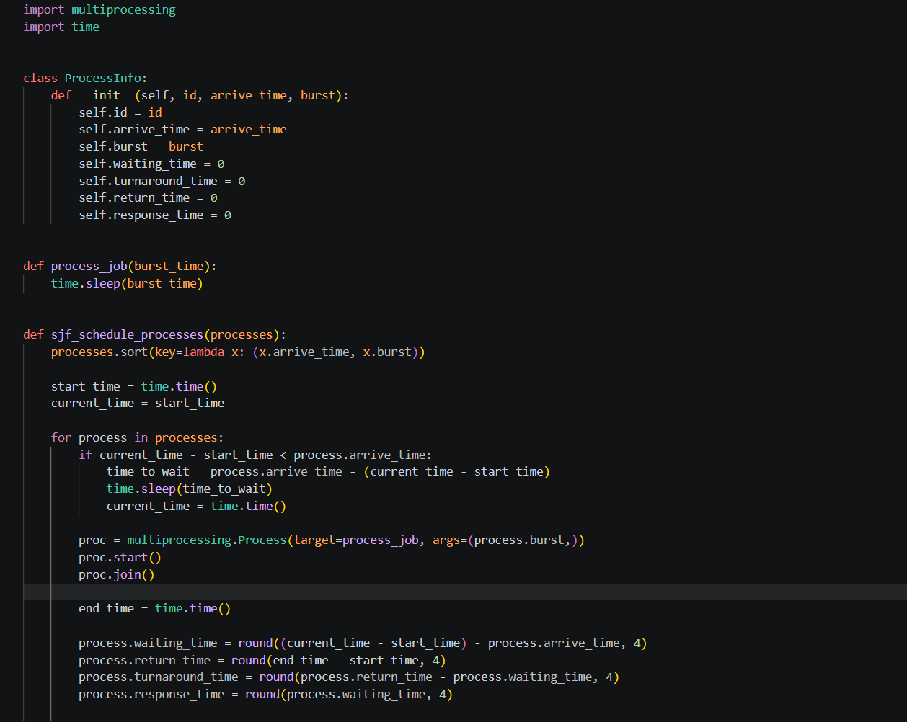

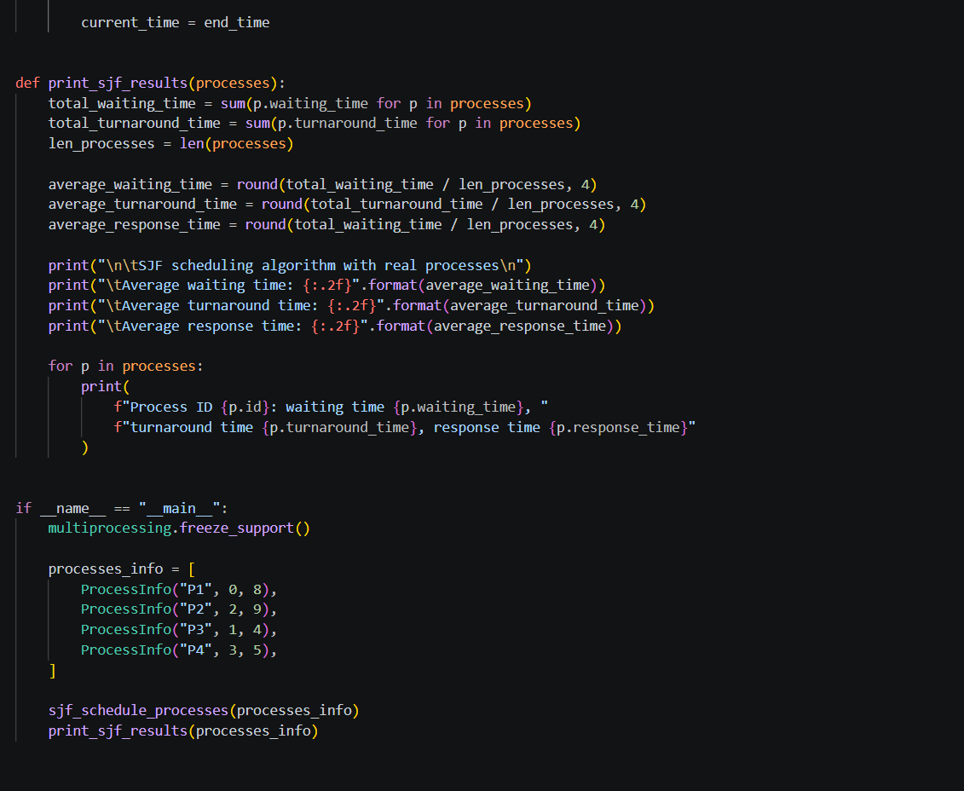
Explanation: The Shortest Job First (SJF) algorithm chooses processes to execute based on the burst times of the processes; the process with the shorter burst time will be executed first by the scheduler. The waiting time and the turnaround time of each of the processes will be calculated and displayed on the screen for the processes that have been executed using this algorithm.
The code defines a class for the processes to have their attributes. The sjf_non_preemptive function selects the next process to execute based on the shortest burst time among all arrived processes, calculates the waiting time and turnaround time for each process, and displays the results. The main part of the code defines the processes to be executed and passes them through the function to simulate the execution of the processes by the SJF algorithm.

Results:
Algorithm | Average waiting time | Average turnaround time
FCFS | 8.75 | 15.25
RR | 13.50 | 20.00
SJF | 7.75 | 14.25

Conclusion:
- Shortest Job First (SJF) - Non-Preemptive
Advantages: More effective than FCFS and RR.
Lower average waiting and turnaround time than FCFS and RR algorithms, which makes SJF more efficient in handling the jobs submitted to the CPU.
Disadvantage: SJF can cause starvation of the processes with longer burst times.

- Round Robin (RR) - Preemptive
Advantages: RR ensures fairness by giving every process CPU time and improves responsiveness in interactive systems.
The average waiting and turnaround time for RR are higher than both SJF and FCFS in this experiment.
Disadvantage: RR depends heavily on the selected time quantum. A very small time quantum increases context switching overhead, while a large time quantum makes RR behave similarly to FCFS.
- First-Come, First-Served (FCFS) - Non-Preemptive
Advantages: FCFS is the least efficient but the easiest to implement.
The average waiting and turnaround time for FCFS falls between SJF and RR
Disadvantage: The main issue with FCFS is the convoy effect, where short jobs must wait for long jobs to be processed.

Ranking:
- Most efficient – SJF
- Moderate – FCFS
- Least Efficient – RR

References:
https://www.geeksforgeeks.org/operating-systems/difference-between-first-come-first-served-fcfs-and-round-robin-rr-scheduling-algorithm/
https://namastedev.com/blog/scheduling-algorithms-fcfs-sjf-rr-priority/
https://thescipub.com/abstract/jcssp.2024.972.985

